# Introduction

Bulldogs Racing has moved from the hybrid category to the all-electric category in the 2016 season for a variety of reasons. First, Yale University has set a major focus on sustainability throughout our daily lives. We think that electric vehicles will be the key to a sustainable future in transportation assuming improved battery technology over the course of the 22nd century. Additionally, the three North American electric vehicle competitions provide more utility for an electric vehicle than the single hybrid competition in New Hampshire. Most importantly, Formula Student has set a trend of electric vehicle performance that has dwarfed previous internal combustion, not to mention hybrid, records. Bulldogs Racing’s 2016 car, BR2016, has been designed for optimal performance across acceleration, skid pad, autocross, and endurance events while still remaining manufacturable and cost conscious.

Our design philosophy can be summed up in this single phrase: “We don’t get to choose not to have problems, but we do get to choose the types of problems we are likely to have.” We do not have a perennial Formula SAE team with a history of success at competition. We do not have significant carry over between teams due to the leadership burning out. Not a single member of the championship 2013 team is on this year’s 2016 team, and only three of our members have been to a competition. Our first step to success has been recognizing these disadvantages, and focusing our efforts on the parts of the car that will benefit us most in competition. The North American electric vehicle competitions have been plagued with poor performances during technical inspection, resulting in cars that do not reach the track. Our number one priority is passing technical inspection with a car that can be successful in all four dynamic events.

# Powertrain

The powertrain of BR16 is made up of the cells, motor controller, motor, and gearbox. All of these components were chosen to operate well with each other. Moreover, the entire package was designed to race competitively in the acceleration, skid pad, autocross, and endurance dynamic events.

## Motor

The design started with the motor, as we found it easiest to adjust other components in relation to the motor rather than vice versa. The goals of motor selection were to traction limit the vehicle up to as high of a speed as possible, maintain greater than 90% efficiency at the average endurance speed, and reduce cost/fabrication time. We discarded any homemade or rewound motors due to the last goal, leaving us with a list of motors from Enstroj, Yasa, Nova, and Allied Motion. Of these choices, the Emrax 207 medium motor matched our goals best in an independent rear wheel drive configuration. We planned to mount our batteries directly behind the driver to drastically lower our polar moment of inertia when compared to side pods. This scheme would not be possible with a chain or belt drive, so we had a choice of direct or planetary gear drive. The Yasa motor lends itself to direct drive, but has a low power to weight ratio when compared to the Emrax. The Emrax 207 Medium has a maximum voltage of 300V, directly correlating with the electric vehicle ruling in North America. Running two Emrax motors each with a gear ratio of 4 results in a top speed of 90mph, traction limited operation up to 40mph, and greater than 96% efficiency from 25 to 50mph. On top of these phenomenal performance characteristics, using two independent motors cuts out the need for a differential.

## Gearbox

To meet packaging requirements, the gearbox had to mount axially to each of the rear motors with a speed reduction ratio of 4. The best solution we found to meet this need was the planetary gearbox. Following our design philosophy, we searched for a planetary gearbox that could be dropped into the car using only mounting tabs and half shafts rather than designing the gearbox ourselves. Unfortunately, we could not find such a product and had to settle somewhere in between. The Matex 146-4MEF planetary gearbox fit our reduction ratio needs at the cost of designing a watertight housing to meet manufacturer-suggested lubrication specifications.

## Motor Controller

The motor controller’s primary design specification was to match the motor type, voltage, and current while remaining efficient, low cost, and easy to integrate. Additionally, we wanted a motor controller that could perform in all four quadrants for regenerative braking. Enstroj suggested using the Bamocar D3 400-400 motor controller with the Emrax series of motors. We decided to follow their suggestion in order to ensure compatibility between the motor and controller. While the Bamocar motor controller is fairly lightweight, it wastes a lot of space volumetrically. We repackaged the motor controllers in a lower footprint housing in order to fit them behind the driver’s seat. This, again, is an example of a compromise we had to make between designing an entire component from scratch versus buying a drop-in component off the shelf.

## Cells

The accumulator cell was the most difficult component of the powertrain to choose due to the wide performance gap between designing and purchasing battery packs. Most off the shelf battery packs that we found did not meet our requirements for nominal voltage, continuous current, peak current, specific power, specific energy, energy density, and form factor. The only suitable battery pack we found was the A123 AMP20 energy module, but we could not find a supplier that sold them. Between lithium cobalt cells from Tenergy, Haiyen, and Turnigy and lithium iron cells from A123 we looked for a cell that would meet our requirements while resulting in a manufacturable and reliable battery pack. Our main focus was on high capacity cells such that the battery pack could be a series string of cells, forgoing the parallel cell fusing rule. Additionally, higher capacity cells would require less overall cells, resulting in easier fabrication and higher reliability. The A123 AMP20 cell used in the A123 AMP20 energy module was selected for numerous reasons. Its 20Ah capacity allowed us to design an accumulator with an 86S1P configuration with a maximum voltage of 300V. Its 600A peak current aligns well with two times the Emrax 207 Medium’s peak current rating. Lastly, AMP20 pouch cells are aligned face to face in compressed cell stacks that fit well between the driver’s seat and rear axle.

# Vehicle Dynamics

Designing the vehicle dynamics systems for a Formula SAE race car is a tall order, and requires a thorough understanding of the both the SAE rules, and the systems that make up a car. For instance, the Formula SAE rules specify an average speed between 25 and 30 mph. Therefore, aerodynamics is not as important as it is in other major racing series. This means that most of the external forces that the vehicle sees are transmitted through the tires, and therefore the tires must be selected first and foremost. Once the tires are chosen, the suspension, braking, and steering are designed in parallel to keep the tires in their optimal state while meeting packaging needs. Finally, the chassis is rigidly formed around these systems to allow room for a driver, powertrain, and other auxiliary systems. Unfortunately, Bulldogs Racing's 2016 chassis was complete before the selection of tires and design of suspension, therefore this model could not be followed in its entirety. However, the suspension, steering, and braking were adapted from Bulldogs Racing's 2013 championship car and optimized for the chosen tires.

## Tires

All forces produced by the powertrain in acceleration and cornering are reacted through the tire contact patches at low speeds. Therefore, it is important for the chassis, suspension, braking, and steering systems to keep the tires in their optimal state throughout all conditions that may be achieved on the track. However, determining this optimal state is another problem in and of itself, usually achieved through the analysis of tire data.

### Tire Data

The Formula SAE Tire Test Consortium (TTC) has partnered with Calspan to produce tire data on the most common Formula SAE 10” and 13” radius tires from Hoosier, Goodyear, and Avon. The tires are swept through slip angles on a steel belt, where rim width, pressure, tire load, and camber are independently varied to produce data for longitudinal force, lateral force, aligning moment, overturning moment, tread temperature, etc. This data can be analyzed for peak values, fit to curves, and fit to models to characterize the performance of the tires in various states.

### Tire Selection

Tire selection depends mostly upon rear weight bias, of which Bulldogs Racing's 2016 car will have about 60%. Tires should be picked such that the peak coefficient of friction for the outside rear tire under 30% load plus load transfer should be equal to the peak coefficient of friction for the outside front tire under 30% load plus load transfer. Doing this will ensure that the two sets of tires begin slipping from the track at about the same lateral acceleration. Aside from matching the fronts and rears in this manner, the tires with the highest possible coefficients of friction should be chosen to maximize vehicle performance.

Due to time constraints and a small one-man tire team, tire selection was limited to finding peak values and fitting magic formula curves rather than developing extensive tire models. The data was parsed into runs with constant rim width, pressure, vertical load, and camber. Figure 1 (left) shows five example data sets of cornering force vs. slip angle for a 7.5” Hoosier tire on an 8” rim width at 10psi of pressure and 0 degrees of camber. After the data was parsed into a usable format, each data set was fit with Pacejka's magic formula to determine peak coefficient of friction values for both longitudinal and lateral forces. MATLAB's nonlinear least squares curve fitting tool was used to create the fits, one of which is shown in Figure 1 (right).

The peak longitudinal and lateral peak coefficient of friction values from these fits were compared for a 6”, 7”, and 7.5” Hoosier along with a 6.2” and 7.2” Avon and a 7” Goodyear. Similar tire widths' coefficients of friction were compared when looking between manufacturers as both the full line of Avon and Goodyear Formula SAE tires were not tested by the TTC. The Hoosier tires had the highest coefficient of friction in both the lateral and longitudinal directions. Additionally, the coefficients of friction for the 7.5” and 6” Hoosiers matched that needed for a 60% rear weight bias vehicle, which is the design goal for Bulldogs Racing's 2016 car.

### Tire Analysis

Once the runs were fit, the peak coefficient of friction values were averaged across multiple dimensions and compared between differing tire manufacturers and models. Peak coefficient of friction was averaged across all dimensions except for rim width to determine optimal rim width. Then that rim width was chosen for future analysis. Next peak coefficient of friction was averaged across all dimensions except for rim width and pressure to determine optimal pressure at the optimal rim width. Then that pressure was chosen for future analysis. Finally, a plot of lateral force versus vertical force for multiple cambers was generated at the optimal rim width and pressure to determine tire camber sensitivity as shown in figure 2. This analysis was completed for both the front and rear Hoosier tires such that the suspension could be designed to keep the tires happy.

## Suspension

A double wishbone geometry matches the design goals for most Formula SAE cars, and is therefore prevalent across the competition. Independent wheel movement is a must in order to operate at high accelerations on bumpy Formula SAE tracks. Independent adjustment of major suspension parameters such as ride height, toe in/out, and camber is important, and easy to implement into a double wishbone geometry. It is also possible to work out the loads in each of the six members of a double wishbone geometry making for a trustworthy static analysis, and therefore a much more reliable car.

Most of a double wishbone suspension has to be manufactured in house to achieve the designed geometries. In an effort to remain true to our design philosophy, the hub-bearing-rotor assembly was bought from RCV performance such that the team could focus on the parts of the suspension that would more directly affect vehicle performance.

### Geometry

Double wishbone suspension geometry determines the path through which the tires take, ignoring any poorly designed compliance issues. The goal of this geometry is to minimize camber change, track width change, and roll center change as the suspension moves in bump, droop, and roll. A compromise is required as reducing each of these variables independently conflicts with the others. Selecting a working tire camber range started at the tire data, and was carried out independently for the front 6” Hoosiers and the rear 7.5” Hoosiers.

Note in figure 2 that the 7.5” Hoosiers performed best at 0 degrees of camber, and therefore the suspension should be designed such that the outside, more heavily laden tire has 0 degrees of camber during a turn. Figure 3 shows the 2D geometry sketch by which a trial and error process was used to determine optimal parameters. Note that a more robust method would have involved a track simulator with tire models, but we did not have the time to implement such a solution. The change in camber was adjusted to about 2 degrees for a 2.5 degree roll, thereby compromising between tire camber and roll gradient performance. The static camber was left very low, namely -0.5 degrees in the front and -1 degree in the rear because the uprights will have built-in static camber adjustment through shims, but only in the negative direction. Additionally, the front and rear roll centers were kept as close as possible to each other in both height and lateral offset such that the roll axis remained constant relative to the vehicle mass centroid axis.

### Adjustability

Suspension fabrication is by no means a perfect process. The chassis fabrication took place at a separate facility from the suspension fabrication resulting in the use of multiple jigs. Attaining accurate geometry placement with just a single jig is difficult. Therefore, 1.5/16” tolerances were used for all of the suspension nodes to account for chassis fabrication inconsistencies. While this may lead to unexpected performance on the track, suspension adjustability can account for these fabrication tolerances along with individual driver tastes.

A multitude of suspension parameters are statically adjustable between races. Toe can be adjusted due to a left and right handed rod end being used on the front steering link and rear toe rod. Ride height can be adjusted by the same method’s use on the pull rods. Additionally, this ride height adjustment is independent of spring preload, which is adjusted directly on the damper. Kingpin axis inclination is adjustable by the threaded rod ends on the front wishbones, although this adjustment will slightly change other suspension properties such as camber, track, and roll center sensitivity to bump, droop, and roll. Steering arm and Ackermann are adjustable through steering link tabs that bolt to the front uprights. Finally, camber is adjustable through shims on the bottom of each front and rear upright.

### Uprights

The suspension uprights connect the wheels to the six links that return to the chassis through a set of two back to back tapered roller bearings. These components were manufactured from 7075-T6 aluminum to reduce weight and compliance. Bulldogs Racing's 2013 uprights were improperly simulated, therefore they were much stronger than they needed to be despite their advertised safety factor. Additionally, the old uprights used a lot of weight where it wasn't needed.

Figure 4 shows the old and new front uprights along with the old and new rear uprights. At first glance, note that the same bearings, hubs, and wheel centers were used, therefore the design of the upright can be isolated from the rest of the suspension. Additionally, the old rear upright is mirrored for the left side of the vehicle while the rest of the uprights pictured are for the right side of the car.

A variety of major changes were made to the front and rear uprights. The front and rear uprights were thinned from 1.95” to 1.4” and 1.5” respectively. A removable plate was added at the bottom wishbone attachment point to allow for camber adjustment. Two #10 socket heads hold the camber adjustment plate in place. The front camber plate includes the steering arm so that adjusting camber does not require a steering rod length adjustment, therefore keeping the same bump steer setting as before the camber adjustment. Two steering link tabs are attached to the front uprights camber plate to allow for adjustment of bump steer and Ackermann independently of camber. The rear upright upper wishbone attachment point was moved off center to accommodate a larger toe base. This reduced loads and compliance through the toe rod giving the driver better control over the vehicle.

In terms of weight savings, the new upright pockets were cut completely through because simulation showed that leaving a thin layer of aluminum on the back of the upright does not significantly increase strength or rigidity, but drastically increases weight. Additionally, a triangular structure was run to either side of the wishbone and toe link attachment points on the uprights to better support the nodes. A weight of 1.71 and 1.98lbs was achieved for the front and rear uprights respectively with a safety factor of over 5, as opposed to about 3.16 and 3.37lbs for the old car.

## Steering

A Stiletto 12:1 rack and pinion was used to transfer steering forces from the wheels to the steering column and driver. Four brake calipers were used at the front of the car to produce enough braking force for BR13. To reduce weight and system complexity, Wilwood master cylinder and caliper bore diameters were selected such that only two brake calipers needed to be used at the front of the car, resulting in a total of four calipers on the vehicle. Additionally, the bore diameters were selected such that braking force distribution matched 2g longitudinal load transfer for a 40% front biased vehicle.

# Chassis

BR16’s chassis is a close iteration of BR13’s chassis with changes for suspension, packaging, and weight savings. A steel spaceframe construction was used to reduce cost and labor. However, the most important benefit of the steel spaceframe was the ability to weld directly to the chassis when things didn’t work out as planned. Bulldogs Racing does not have the capability to finalize vehicle design by winter of the year before competition, so welding tabs throughout fabrication was an advantage.

## Improvements

To start off, we were able to reduce both the height and length of the chassis due to packaging design considerations made before the summer of 2015. The width could also be reduced because the vehicle no longer needed to house both an electric motor and internal combustion engine in parallel. The rear box that used to house the differential, but now houses the motors and gearboxes was significantly reduced in size due to the lack of large chain driven sprockets. Lastly, the driver seat angle was increased to 45 degrees to give more room for the accumulator in the area directly behind the seat. A weight of 65lb was achieved, directly in line with our goal of fabricating a chassis that weighs less than 70lb.

## Fabrication

The tube cutting and welding of the chassis was outsourced to a local race shop over the summer of 2015. Both the lack of welding experience, and time to correctly jig a chassis were key contributors to the decision to outsource fabrication. The high tensile strength, ease of welding, and low cost of 4130 steel made it the obvious choice as the chassis material. Tubing was TIG welded together using ER80S-D2 filler rod. All structural tabs were cut from 0.1” 4130 stock and welded directly to the chassis.

## Aerodynamics

We determined early on that aerodynamics would not bring a big enough benefit to BR16 to warrant significant investment in front/rear wings or a diffuser. As noted earlier, most electric teams do not make it past technical inspection, not to mention finish the endurance race. Additionally, the fairly slow average speeds of Formula SAE racing mean that a competitive vehicle can largely ignore aerodynamics as long as tire, suspension, chassis, and powertrain design are done correctly.

Despite our lack of experience, we made a few common sense design decisions to take advantage of aerodynamics with BR16. Frontal area of the cockpit opening was reduced as much as possible in chassis design to reduce aerodynamics drag. Additionally, our contoured body prevents laminar-turbulent flow transition, again reducing drag. Lastly, NACA ducts on either side of the driver’s head pull air into the radiator that cools the motors and motor controllers.

# Ergonomics

BR16 was designed to fit every height from a 5th percentile female to a 95th percentile male through adjustability of ergonomic components. Additionally, driver controls were made simple to the novice racer through the use of a two pedal throttle/braking system and a hand lever for regenerative braking.

## Adjustability

A carbon fiber seat was molded to the cockpit opening such that it was much larger than needed, even for a 95th percentile male. Foam inserts were then used to fit various drivers to comfort and change driver height if needed. A vertically adjustable headrest ensures that the driver’s head and neck are well supported in acceleration and cornering. Tilt lock adjusters on the anti-submarine, shoulder, and side belts of a six-point harness keep the driver securely fastened to the seat. Additionally, the pedal box slides on longitudinal rails such that it can be adjusted per drivers’ leg lengths.

## Dashboard

The BR16 dashboard consists of a speed and fuel gage to keep the driver well informed during the endurance race. AMS, IMD, and software fault lights make electrical troubleshooting easier. An electronic braking hand paddle attached to the steering wheel increases endurance performance through selective regenerative braking. Additionally, an autocross/endurance switch toggles between throttle mappings for performance and efficiency.

# Systems Engineering

Bulldogs Racing uses a rigorous design review structure and active project management to oversee and integrate the complex systems that comprise a Formula SAE vehicle, while still maintaining healthy social relationships between team members. The design review cycle consists of preliminary, intermediate, and critical reviews that aim to move designs in the correct direction at appropriate speeds.

## Design Review Structure

The design review process is broken into three main phases with the following goals: direct the design team in a constructive way, evaluate the durability of the design, and confirm manufacturability. At the preliminary review a project team outlines alternate solutions to the problem. The presiding chief engineer and project manager discuss alternatives and pick which system will be further developed. At the intermediate review, a fleshed out design is evaluated for structural integrity and compliance with rules and other vehicle systems. At the critical design review a professional familiar with the system reviews the design and provides feedback regarding the manufacturability and quality of the design. This process of constant review produces simple, robust designs.

## Active Project Management

Project management’s duty is to ensure that all systems are installed logically and safely within the vehicle, while still maintaining healthy social relationships and academic standings. Project management uses two main resources to accomplish these goals: weekly meetings that determine health of the team and goals for the week, and a repository that contains all design and system information. At each weekly meeting the goals for the week are set with human resources (potential progress) and desired progress in mind. A balance between the two is sought for and goals for the week are determined. These goals are stored in a repository accessible by all team members. Additionally, the repository houses work orders (documents with project timeline, research findings, and bill of materials) and engineering part/assembly designs (CAD models). This repository is constantly updated so that design and logistic information can easily be shared with the team. The repository, coupled with design reviews and weekly meetings, ensures that systems are designed and located in logical, timely manners

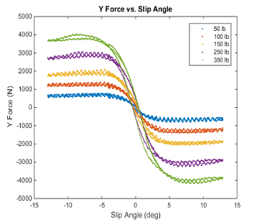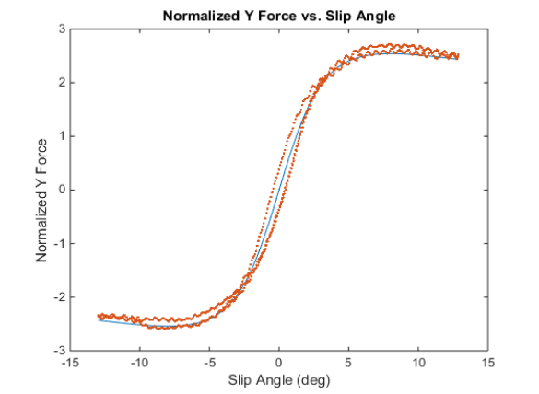

Figure 1 – TTC parsed tire data (left) fit to Pacejka’s magic formula (right)

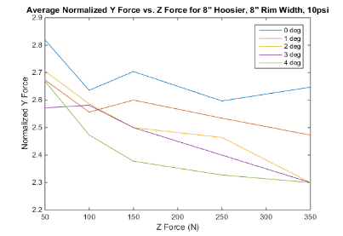

Figure 2 – Lateral vs. vertical force for rear tire cambers (listed cambers should be negative)

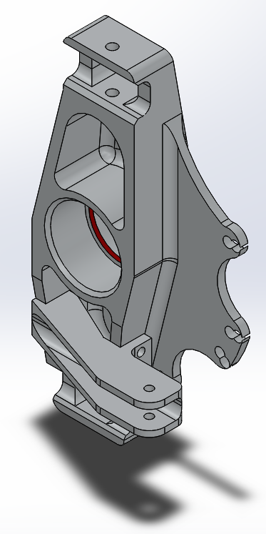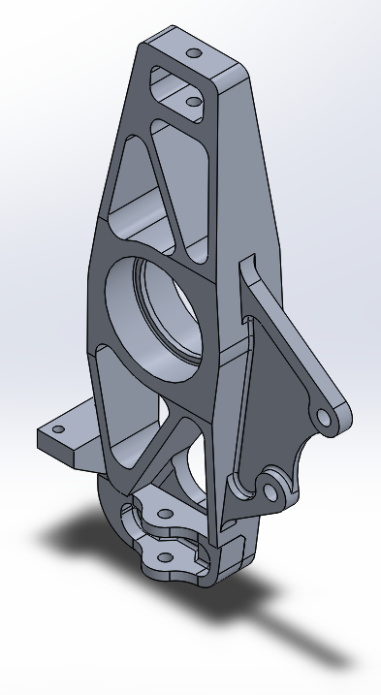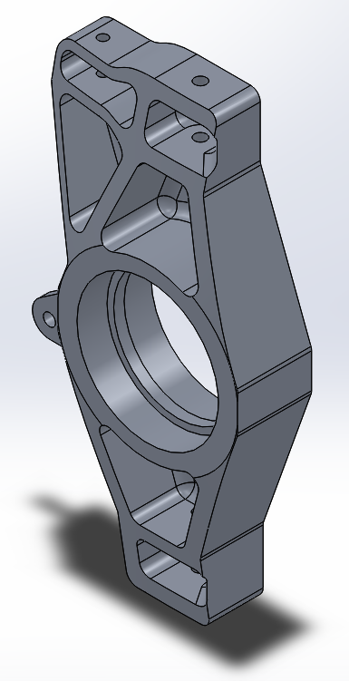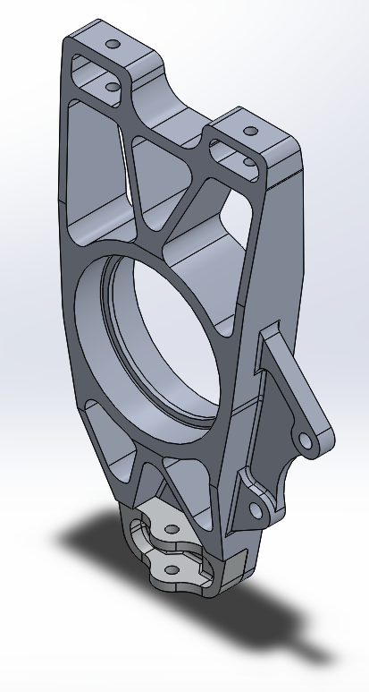

Figure 3 – From left to right old front, new front, old rear, new rear